**DAILY ONLINE ACTIVITIES SUMMARY**

|  |  |  |  |  |  |  |  |  |
| --- | --- | --- | --- | --- | --- | --- | --- | --- |
| **Date:** | **30-05-2020** | | | | | **Name:** | **Preethi** | |
| **Sem & Sec** | **6th - B** | | | | | **USN:** | **4AL17CS065** | |
| **Online Test Summary** | | | | | | | | |
| **Subject** | | **Python Application Programming** | | | | | | |
| **Max. Marks** | | **30** | | **Score** | | | **12** | |
| **Certification Course Summary** | | | | | | | | |
| **Course** | **Introduction to Information Security** | | | | | | | |
| **Certificate Provider** | | | **greatlearning** | | **Duration** | | | **5.5 hours** |
| **Coding Challenges** | | | | | | | | |
| **Problem Statement:1 Python and 1 Java program** | | | | | | | | |
| **Status: executed** | | | | | | | | |
| **Uploaded the report in GitHub** | | | | | **Yes** | | | |
| **If yes Repository name** | | | | | <https://github.com/PreethiNayak/Daily-Status/tree/master/30May2020> | | | |
| **Uploaded the report in slack** | | | | | **Yes** | | | |

Online Test Details: (Attach the snapshot and briefly write the report for the same)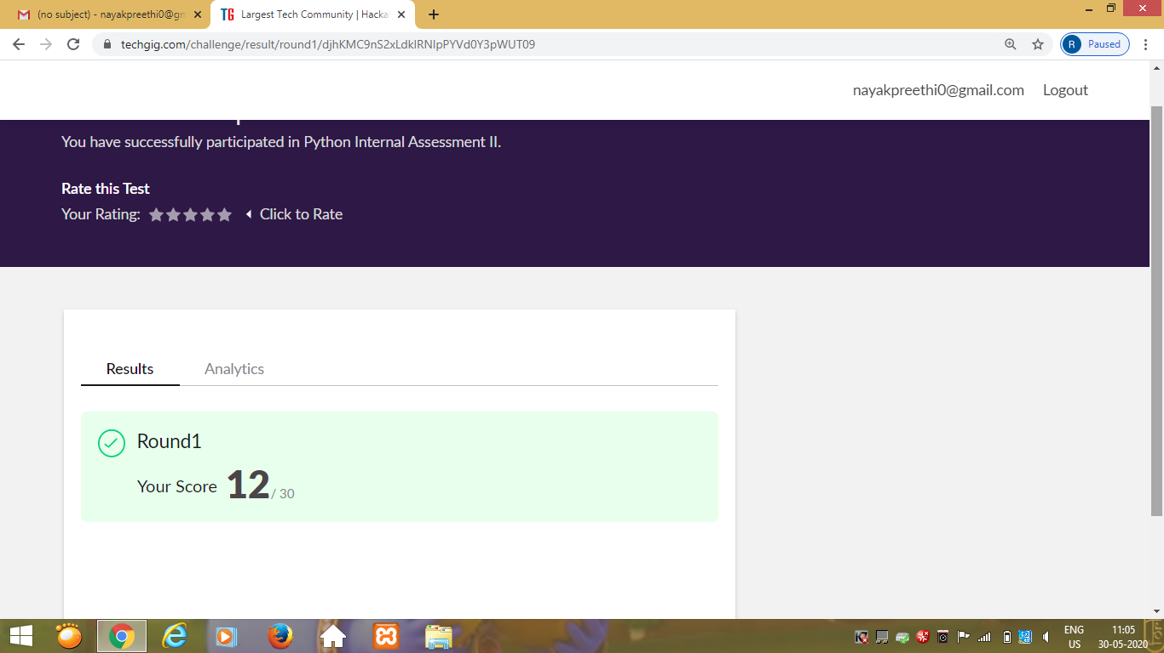

Certification Course Details: (Attach the snapshot and briefly write the report for the same)

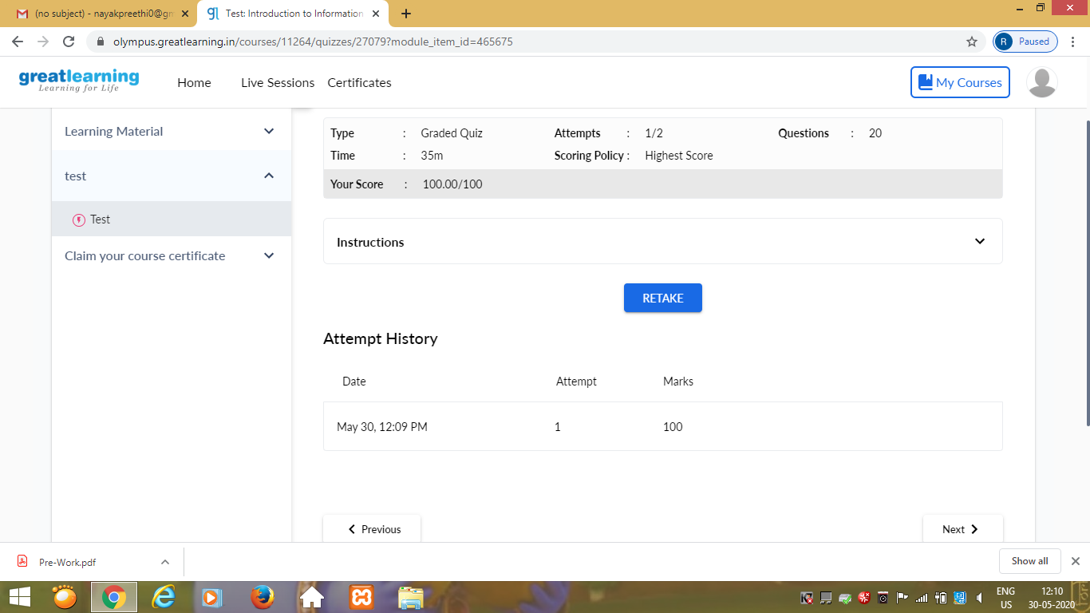

Today I took quize on Introduction to Information Security course and completed this course.I have uploaded certificate in GitHub.

Coding Challenges Details: (Attach the snapshot and briefly write the report for the same)

Program 1

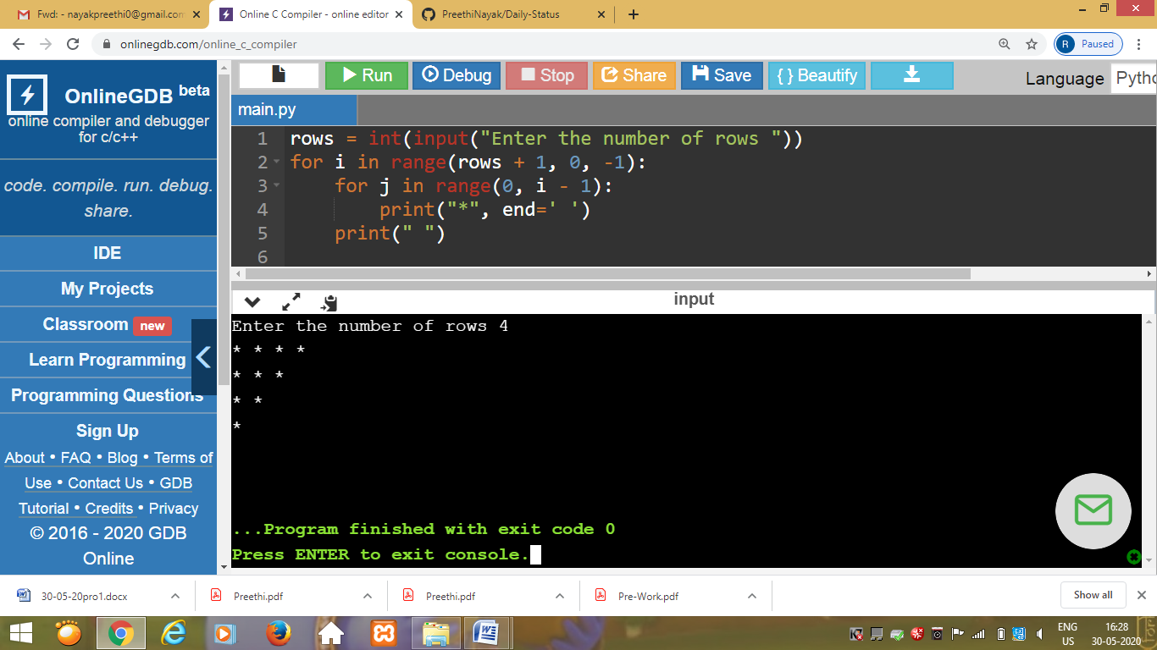

This is output of python program to read the number and print the pattern as in above snapshot.

Program 2

This is the output of the java program that displays the number of trailing zeros in the product of Array.

